Gabi Spurlock
MUSE 353
Mid-term
Cultural History
Lady Gaga’s “Million Reasons,” from the new album, Joanne, is a different type of music than the usual music she produces. Lady Gaga began her music making career at a young age and attended a music school in New York. Before graduating, she left and started her career making music. In 2007, she signed a record contract and within in a year, released her first album that introduced the public to her music.
The first album, The Fame, contains many of Lady Gaga’s most well known songs. When the most recent album was released, the general buzz sparked surprise at the different styles between her other albums and Joanne. “Million Reasons” is a track on the newest album. In comparison to the pop sounds of the first album, this one is more expressive with more variety within the single track. Other tracks on the album also portray a similar variety by contrasting her previous works so drastically.
This album has contributed to the field in a few socially interpreted ways. For one, Lady Gaga was a popular artist for her dance hits. Since the first album release, she has become famous and made a name for herself. This album was the sixth of Lady Gaga’s albums. The past two have been in a different style than the previous ones. This change in style is a clear step in a different direction. The name she has made for herself as a female artist that is breaking out of the conformity is a valuable lesson for students going through adolescents.
The other track, “Million Reasons,” by Molotov Cocktail Piano, is a cover of Gaga’s track. Molotov Cocktail Piano is a cover group that remakes pop songs into piano pieces. The cover of this particular piece has a very similar feel to Lady Gaga’s performance. Molotov Cocktail Piano however is instrumental only and has no lyrics.

Venn Diagram

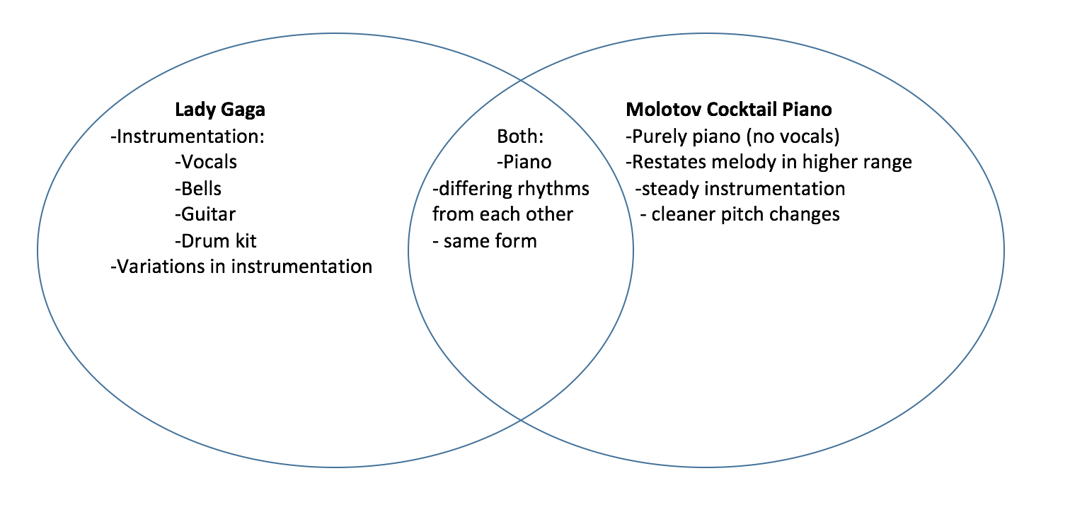

Hello dear friend,
I was preparing a lesson for class this week and came across a new recording I hadn’t heard before. Lady Gaga just released a new album with many songs that seem unlike the pieces I’m used to her performing. This change in style caught my ears and I found that I really enjoy this piece and think my students would also enjoy it. Of course, simply enjoying it is not merit enough to bring it into the classroom. I then found a cover of this song by a piano cover group, called Molotov Cocktail Piano. This was also entertaining to listen to. But still, I need to find a valuable reason to bring it into my class.
Using a lyric dictation would be simple enough. After the students hear the melody with the lyrics in the original, we could then apply the lyrics to the piano cover and assess if they’re hearing the same melody in a different timbre with different instrumentation.
On the other hand, using a perception chart would insist they listen more closely to the piece. Since the form is verse-chorus, the lyrics are rather repetitive and a perception chart would ensure they still hear the lyrics time and time again. Applying a similar perception chart to the Molotov Cocktail Piano cover would assist the students in discerning details by listening to piece that is just as repetitive but from a different artist.
Providing the students with two perception charts will mean playing through each piece at least twice for them to discern differences. Perhaps playing Gaga’s recording twice before playing the Cocktail Piano piece. Then returning to Gaga’s performance. This way they have ample time to listen for the various instruments in the background as well as some rhythmic variations in the accompaniment.
On the other hand, a rhythmic dictation would also be a useful tool because anytime the class can learn more about rhythm and practice their aural skills is a successful lesson. Rhythmic dictation may not be the best use of this material though. Analyzing the rhythm will require a little bit of interruption within the lesson. We will have to listen to a portion of the piece and find the beat before determining the rhythmic pattern. After we’ve learned one pattern by rote, we will then find a similar place in regards to the form and assess if the rhythm in the other arrangement matches the first pattern or not.
The same kind of assessment could be applied to tonal patterns. Then we can possibly use neutral syllables to transfer pitch patterns to solfege. Giving students the tools to recognize the melody and compare it to the melody in the cover will show their understanding of the variation. To help them understand some of the other variations, as the class can discuss the perception charts and assess what else may be different between the arrangements. One of the differences the perception chart will lead them to is the instrumentation. The Lady Gaga arrangement has several different instruments that creates a variety of textures and timbres. However, the Molotov Cocktail Party arrangement is purely piano, and even lacks vocals. These are some of the more obvious differences, but details the class will notice just the same.
From here, students could create and arrange their own variations of the same melody. I would be sure to give them specific guidelines. For example, maybe altering the tempo, or changing a singular pitch in places. Another variation could be in the rhythm with more rhythmic divisions or even adding rests. These changes are fairly simple and asking them to make only three of these changes will help them to arrange their own version.
I think after walking through the options before me, I will use the perception chart. Listening to each piece twice with the chart and then discussing each will help me to understand better where the students are, not just ensuring they can repeat a melody back but rather look a little deeper to notice differences within the arrangements.
Thank you.

Glossary
- Accompaniment- The part of the music that supports the melodic line with a variety of instruments and harmonies.
- Arrangement- Another version of a song.
- Aural skills - Skills developed to build music literacy and ear training to dictate what is being heard.
- Cover- An arrangement that is nearly the same as the original work, but by a different artist.
- Form- The breakdown of a piece by phrases.
- Instrumentation- Way to describe what instruments are in a piece.
- Lyrics- The text that accompanies vocal pieces; the words being sung by the performer.
- Lyric dictation - A worksheet that provides most of the lyrics for the class, and the words not provided are indicated by blanks for the students to fill in.
- Melody- The most discernable line in the piece; where the ear is drawn to.
- Neutral Syllables- Syllables such as pa, or da, that do not coincide with any solfege syllables.
- Perception chart- A tool used to engage students in listening to a piece. Provides the option of two answers and assesses the student’s understanding.
- Pitch- The location of a pitch based on soundwaves. Can be higher or lower.
- Pitch patterns- Patterns of arranged pitches from any part of the song.
- Rhythm- Groups of various lengthed sounds.
- Rhythmic dictation- Recording patterns of rhythms in a designated worksheet for students.
- Rhythmic pattern- Patterns of rhythms from within any part of the song.
- Rhythmic variation- Taking a rhythm from another piece, or a different part of the same piece and altering it any degree of a way.
- Solfege- Designated syllables to address a specific pitch.
- Style- Determined by a number of recurring musical characteristics that build an artist’s style.
- Tempo- The rate at which the music occurs.
- Texture- The layout of voices within a piece, or portion of a piece.
- Timbre- The tone and color of a specific voice or combination of voices.
- Tonal patterns- Similar to pitch patterns, patterns of arranged tonal phrases.
- Verse-chorus form- A common form for popular music that is built on the alternation of verses and choruses.
- Vocals- Part of the music performed by a vocalist, or singer.

Lesson Plan
Grade Level: 6th grade |  | Lesson Length:20-25
Major Concept Focus | Melodic variation
National Standard(s) | 1. Singing alone and with others, a varied repertoire of music.  4. Composing and arranging music within specific guidelines.  6. Listening to, analyzing, and describing music.  7. Evaluating music and music performances.  9. Understanding music in relation to history and/or culture)
Materials Needed | - Recording of each piece.  - Copies of charts
Literature Titles &  Media Source (if any) | Lady Gaga, “Million Reasons”  Molotov Cocktail Piano, “Million Reasons”

Objectives:
- Complete Perception charts.
- Discuss differences of each recording.
- Students will perform melody of the chorus. (first in neutral syllables, then in solfege).
- Students will perform the bass line of the chorus (first in neutral syllables, then in solfege).
- Perform the melody from the original while listening to the cover piece.
- Set parameters and let students create their own variations.
Planned Sequence:
Introduction: Hello class! We’re going to listen to a couple of songs today as well as learn the chorus. But I want to know first, have you ever worked really hard at something, and it just keeps going wrong? And after you’ve tried and tried, you think to yourself, if only one thing could go right, I could keep going.
This song we’re going to listen to has lyrics that tell a story like that. But first, how many of you know Lady Gaga? Which songs are you familiar with?
- Objective 1: After shortly discussing what knowledge students have of Gaga’s career, I will be sure to clarify the following points:
  - Started out in an arts school and had been a musician since a young age.
  - Got a record deal.
  - Released first album in 2008 in a dance/pop genre.
  - Many of the following albums were in the same genre.
  - After establishing herself, she began creating albums that were a more unique genre than earlier works.
  - She is representative of successful female artists in today’s music industry.
- Objective 2: Complete the perception chart for Lady Gaga’s “Million Reasons,” and discuss the answers.
  - Hand out the perception charts for Lady Gaga’s “Million Reasons.”
  - Play the track and instruct students to fill out the worksheet.
  - After listening to the track, discuss the answers.
- Which instrument did you hear first? Was there only one instrument that came in at the start?
- What new instrument was added here? Is this instrument the melody?
- How many vocal parts did you hear? Was it one, or more than one?
- What was the most prominent voice you heard? What was the voice that stood out the most to you?
- Did you hear a brass section or drums enter?
- Were some of the lyrics we heard the same as previous lyrics? Or all different?
- Same as number 6.
- What instruments are in the background? Did you hear any other instruments in the background?
- Are these lyrics repetitive or new? Where else have we heard them?
- Objective 3: Learn the melody of the chorus.
  - The chorus will be taught on neutral syllables for simplicity.
  - After breaking the chorus into pieces and teaching it piece by piece, we will assemble the chorus whole.
  - We will perform the chorus at least twice before moving on,
- Objective 4: Complete the perception chart of Molotov Cocktail Piano’s “Million Reasons.”
  - Explain that many musicians will create covers, or arrangements of successful artist’s work. The next piece we will listen to it a cover of Lady Gaga’s “Million Reasons.”
  - After passing out the next perception chart, we will listen to the Molotov Cocktail Piano’s cover if “Million Reason’s.”
  - Discuss answers:
- What instrument did you hear first? What helped you decide which instrument was performing?
- Which instrument did you hear with the melody?
- Was the melody here the same as the melody we learned? Or did you hear any differences?
- ----
- What were some differences between this piece and the last one?
- Was this melody any different than the first one we heard?
- Was the melody performed at a higher range here than it was in the first performance?
- Objective 5: Perform the melody along with the cover and discuss differences they hear in the melody.
  - Instruct the students to perform the chorus on neutral syllable (pa).
  - After performing the chorus at least twice, we will continue the discussion of melodic differences.
- Objective 6: Discuss any further differences heard within the song that the class may have noticed. Ask students if they have heard covers of other successful artists and discuss some of those artist’s success.
- Objective 7: Now, we will create our own variations of “Million Reasons.’
  - In groups of 4-5, Change at least three things about the melody.
  - Things that can be changed:
    - Tempo
    - Rhythm
    - Pitches
    - Style
    - Add dynamics.
  - You can drop a small portion of the rhythm, add a new note, or adjust the tempo.
  - Students will explain to the class what 3 details were changed and may then perform their variation for the class.

Perception Chart
Lady Gaga “Million Reasons”
Using the chart below, fill in the answer you think best fit as we listen to the recording.
Time | Column A | Column B
1 )0:00 | Piano enters | Guitar enters
2) 0:15 | Guitar enters | Vocal enters
3) 0:30 | There’s more than one vocal part | There’s only one vocal part
4) 0:40 | What’s the most prominent part you hear? | ______________________
5) 1:12 | Brass enters | Drums enter
6) 1:35 | The lyrics are similar to what we’ve heard already | I wouldn’t say these lyrics are similar
7) 1:55 | These are completely different lyrics. | We’ve heard these same lyrics before
8) 2:20 | There are strings in the background. | There are brass players in the background
9) 2:40 | These lyrics aren’t new. | These lyrics are new
Bonus:
What do you think the lyrics are about?

Perception Chart
Molotov Cocktail Piano “Million Reasons”
Time | Column A | Column B
1) 0:00 | I hear a piano. | I hear a cello.
2) 0:15 | The melody is a different instrument. | The melody is the same instrument.
3) 0:46 | The melody matches the first song here. | The melody is completely new.
4) 1:10 | Listen to the accompaniment.
5) 1:50 | Give three words that describe this piece versus the last one:
6) 2:10 | This melody is still familiar. | I’ve not heard this part of the melody before.
7) 2:25 | The melody is in a higher range. | The melody is in the same range.

Bonus:
Which recording did you like more and why?

