Gabi Spurlock
Brass Tech
8 October 2015

Materials needed:
-Students will need instruments
-Extra copy of lesson plan and notation of “Twinkle Twinkle little Star”
Concepts:
-Learning a song by rote on instruments
-Phrasing for beginners
National Standards
1. Singing, alone and with others, a varied repertoire of music.
2. Performing on instruments, alone and with others, a varied repertoire of
music.
6. Listening to, analyzing, and describing music.

Objectives:
- To teach song by rote to students.
- For students to gain an understanding of phrasing.
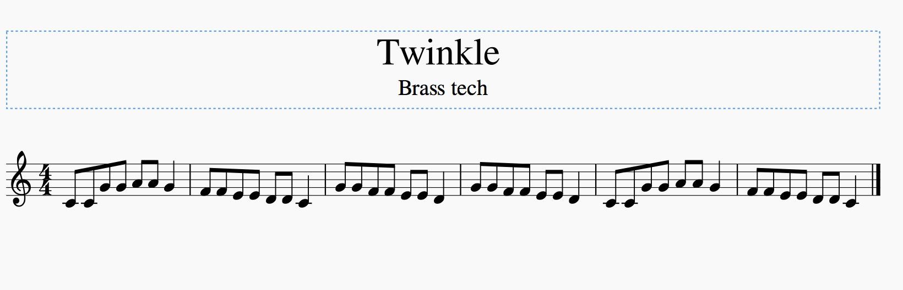
Music selection:
Procedure:
-Greet the class
-“I have a quick song to teach you today but I have a question first. Which sentence sounds more natural? Today, I’m *breathe* going to *breathe* teach you a *song.* or
Today, I’m going to teach you a song.
- Call for answers and explain that breathing disrupts a phrase, or line of music in the same way it disrupts the sentence. So we want to think about where we breathe and how often we breathe when we play.
-Model song with good phrasing then have them sing solfege in chunks while silent practicing along. (Be sure to breathe well and remind them to breathe before each chunk because this will be our phrases)
-Model chunks on trumpet and have students play it back on theirs. Do this for all three chunks.
-Combine for full song breathing appropriately.
    - Recap the lesson: Ask what helps separate a phrase?
    - Great lesson!

